Module 2: Baseline Assessment

Session 5: MArket Assessment

Handout 3 - Basics of Market Assessment

What do we need to find out?
In HEA, we need to understand how households are connected to the market and how that market normally functions. For this, we need to know:
- The terms of trade for households in the zone, so that we can understand what cash income they can make for the goods they sell and what cash they need to spend to pay for basic goods. This involves understanding fluctuations in prices over the year and from year to year.

In order to understand terms of trade properly, we need to understand:
- The relationship between local markets and the wider economy, because it is the demand from this larger environment, and the physical connections between this demand and the local economy that will determine just how much households can benefit from the sale of their livestock, labour, crops and other commodities.
- Any government regulation that may affect prices.

Where do we obtain information on the market?
- Interviews with traders, particularly wholesalers. They can be a useful source of information on past and present prices, normal seasonal price variations, and expected price trends in future.
- Shorter interviews with retailers and producers selling their own produce to obtain price data and other useful bits of market information.
- Secondary information such as historical price data.
- Interviews with other key informants such as district officials and village representatives.

Which markets should we visit?
- You need to check with the local people to find out which markets they use. It could be that the most important market for them is not the local market but a market farther away. For example, the local market might not be a specialist trading location for livestock, even though livestock are sold there in small numbers; a market which is farther away, and on the trade route with markets abroad, might be far more important in determining livestock prices than the local one.
- You then need to find out the market day of each market you’d like to visit. Your market visit needs to be on market day, but it also needs to fit in with your assessment schedule.
- For each market visit you need to organise a visit to two or three traders on the main market day. You will also need to collect price data from retailers and producers selling their own produce.

What information should we collect?
In HEA we focus on the markets for the most important commodities that people sell, and the most important staples that most people rely on when their own production runs out. The most important markets tend to be those for staple foods, livestock and casual labour. Other markets such as those for cash crops or minerals may also need to be considered.

In a typical baseline, we are particularly interested in:

- Price data: current and historic

Current prices
  - We need to find out the prices of the most important items that households buy and sell in the livelihood zone.

  - This data is used primarily to cross check information collected during the household representative interviews on things like prices, weights and volumes of measures. Data collected on the range of prices during the reference year helps provide a basis for developing seasonal fluctuation graphs.

Historic price trends
  - Historic prices provide important evidence for understanding seasonal and year-to-year trends, market integration and marketing constraints for particular commodities.

    - Price data can usually obtained from district offices. Even if there is no formal early warning system it is likely that such data is being collected, even if it is not locally analysed. It might be collected by the Ministry of Agriculture, the Bureau of Trade, the statistics office, or national or international NGOs.

- Information on market efficiency

  - We are trying to find out how well linked the local market is to the wider economy. How efficiently are locally-produced commodities sold on to areas of higher demand? How much of a ‘mark up’ is placed on commodities purchased locally but produced elsewhere?

  - Market inefficiencies are directly related to an area’s relative poverty; if households in Area A get less for their goods than households in Area B, it stands to reason that Area A will continue to be worse off in relative terms.

  - In a year when a shock occurs, households in areas where markets function poorly tend to be less able to use the markets to cope. For example, when crops fail, prices for staple foods are likely to be even higher in an area that is not well connected to the national market infrastructure. This is because regional or national supplies do not reach the local area quickly or at all, leaving the shortfalls in local production unmet. As supplies drop, prices rise.

  - Market efficiency relates to how competitive the market is: do local commodities fetch a higher or lower price in relation to other areas in the country or region? And do local households have to pay more or less in relation to these outside areas in order to obtain basic goods and services? This in turn relates to the extent to which markets are integrated.

  - The basic principle in determining whether a market is integrated is to examine whether prices and changes in price levels for the same good in different markets move in sync with one another when price differences related to transport costs are taken into account. If so, the market is said to be integrated.

  - Information on market efficiency can be obtained through interviews with traders and analysis of price data. Such activities are usually undertaken by market specialists.

- Information on market regulation

  - Despite a push for liberalisation over the past decade, many governments intervene in one way or another in the dominant cereal markets (maize in southern Africa; rice in many countries in south and south east Asia).

  - Regulation can have different objectives, such as:
- Inhibiting traders from selling grain abroad through an absolute ban or a tax on exports;
- Increasing the competitiveness of local farmers by providing them with production support;
- Encouraging people to buy locally by imposing a duty on imports;
- Maintaining a strategic reserve of grain which is released on to the market in times of short supply.

In all cases, these policies have an effect on prices which will in turn affect households’ income and expenditure patterns. It is therefore important to understand the link between government policy and the prices it seeks to regulate.

- Questions in this area of enquiry tend to fall into three categories:
- Market regulation
- Is the market free or is it regulated?
- What are the official market regulation policies?
- Strategic grain reserve
- Is there a strategic grain reserve and how is this managed?
- What role do donors have in maintaining this reserve and influencing the policy?
- Taxation system
- How are official taxes levied?
- Do people have to pay unofficial taxes?
- How are traders taxed?
- Do farmers selling their produce in the local market have to pay taxes?
- Does the taxation system exclude some from trading? Or does it affect how they trade in any other way?

This information can be collected from early warning agencies, donors, government marketing agencies, planning departments, and food relief agencies.

Extract from Interview Form 1: Zone or District Key Informant Interview Format

The section below is extracted from the interview form used with key informants at the district level. It shows the market information that you should try and obtain at this level.

-----------------------------------------------------------------------------------------------------------------------------------------------------
MARKETS: Identify the main source and destination markets for each product, together with the names of any important intermediate markets to indicate a trade route (e.g. local markets -> Chokwe -> Maputo).

Main crops sold | Trade route
1.

2.

3.

Main livestock sold | Trade route
1.

2.

3.

Main foods bought when own stocks run out | Trade route
1.

2.

Market Access
Is market access good or bad in this LZ?
Why?
(e.g. good/bad roads, close to/far from an urban centre)

Labour: How much of the total casual labour performed by people from the zone is undertaken in different locations (e.g. 70% local rural area, 20% local towns, 10% outside of zone)
Local rural area | Local towns | Outside zone | Total
 |  |  | 100%

If outside zone, where do people go?

MARKET PRICE DATA: Request price data for the reference year as well as data for the last five years to present. Ideally, we want information for the main food crops, cash crops, livestock, and daily labour rates. Use the information collected to fill out the table in Annex 2.

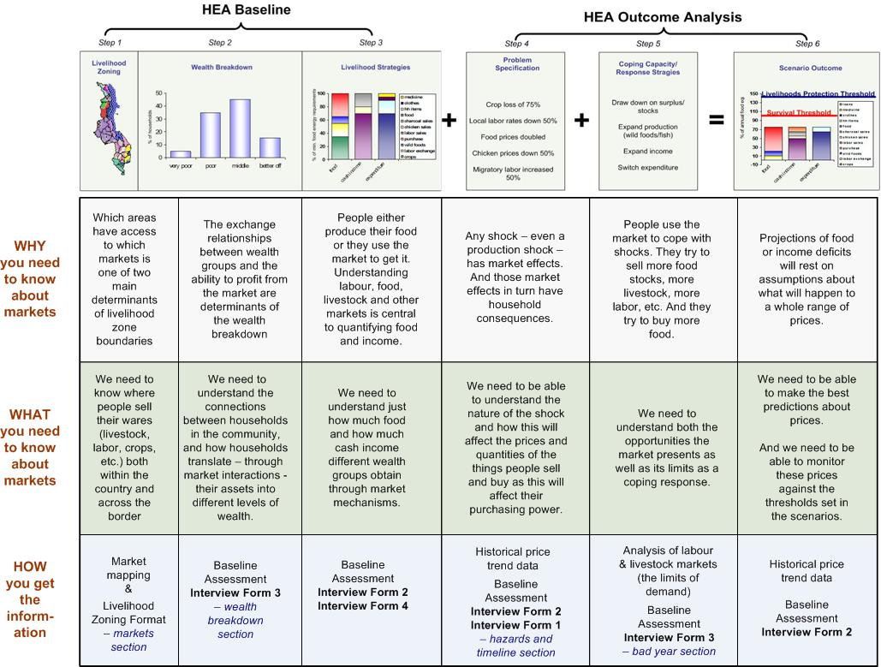
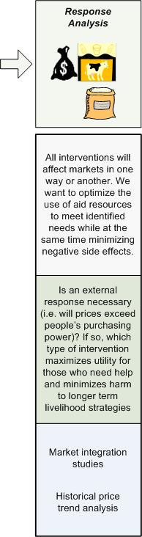
Market information requirements in HEA

